Assignment 12.4 Ai Assisted Coding
Htno:2303a51288
Btno:05
Task 1:
Bubble Sort for Ranking Exam
Scores
Scenario
You are working on a college result processing system where a small list of student scores needs to be sorted after every internal assessment.
Prompt:
Write a simple Python program for Bubble Sort to sort student exam scores. Add inline comments for comparisons and swaps, include early termination if already sorted, give time complexity (best, average, worst), and show sample input/output.
Code:

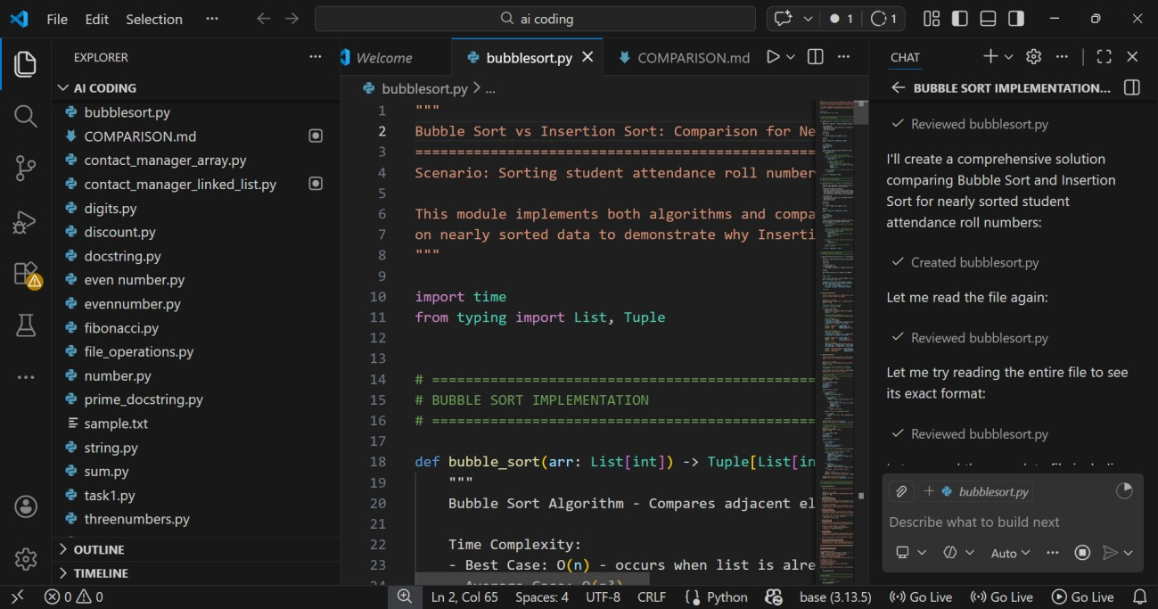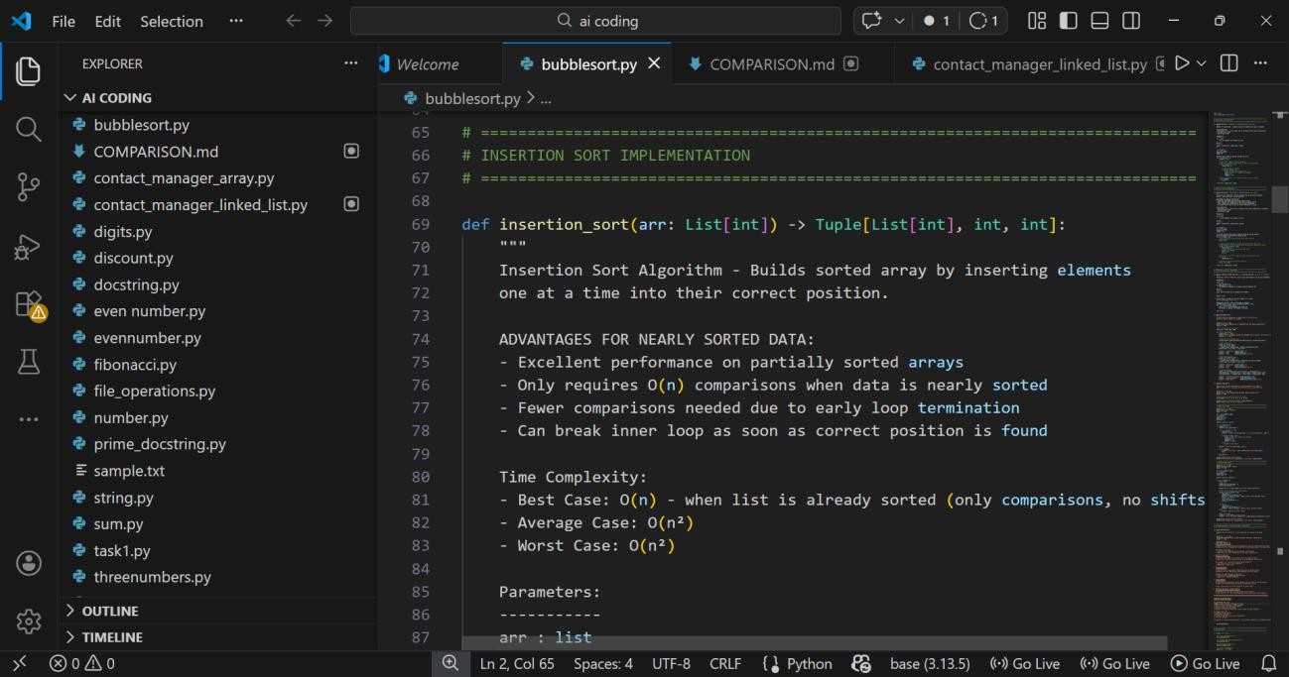
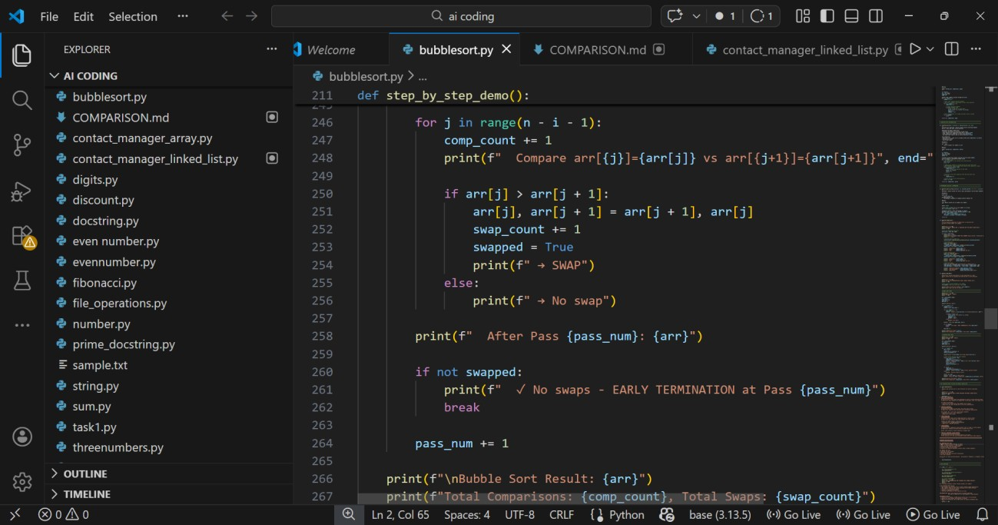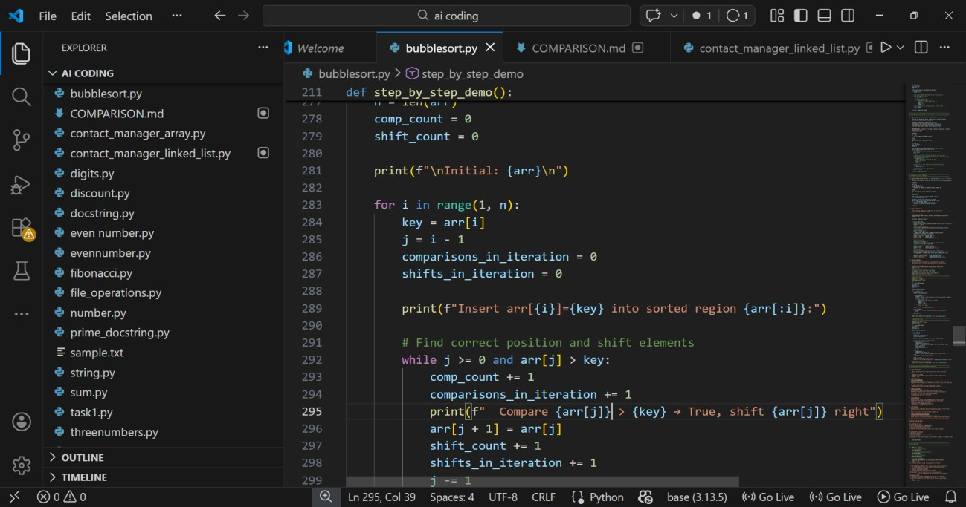

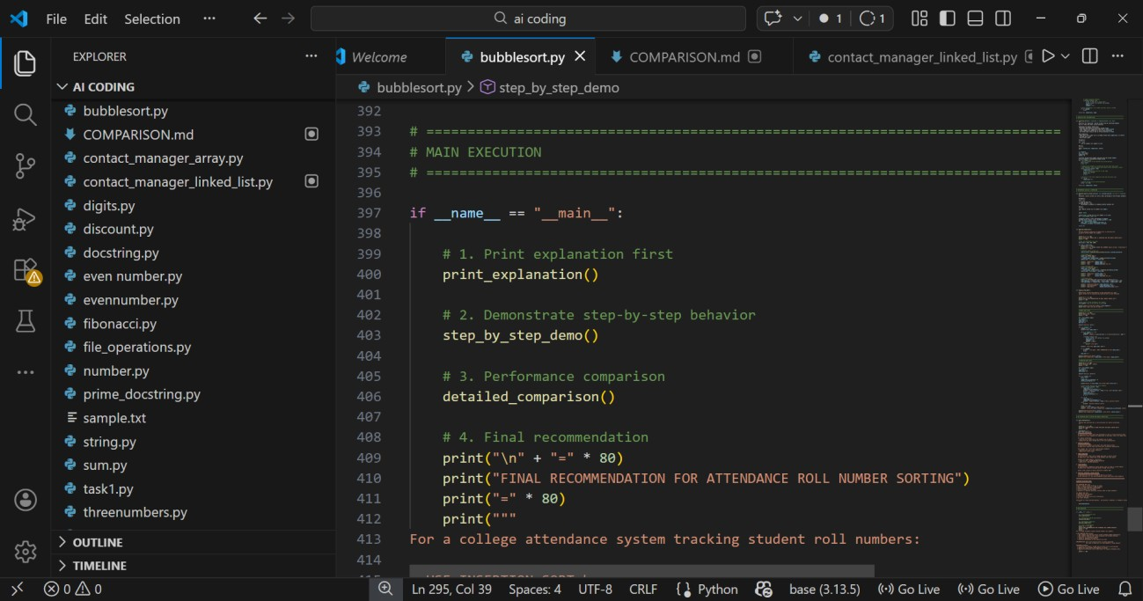
Output:

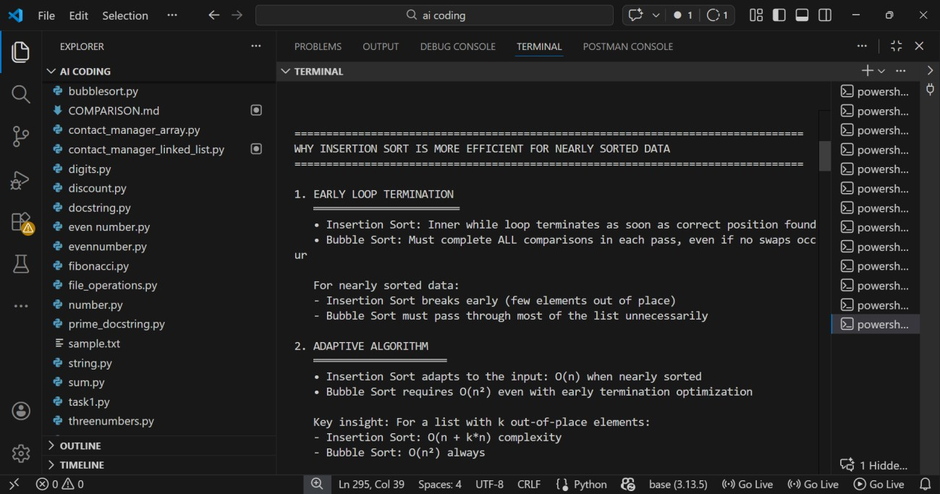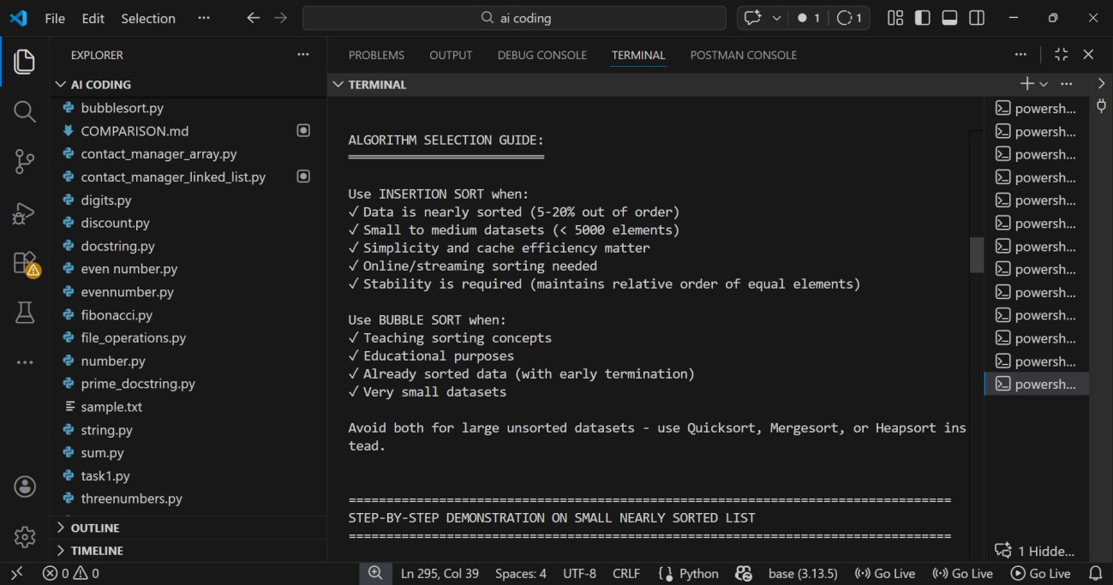
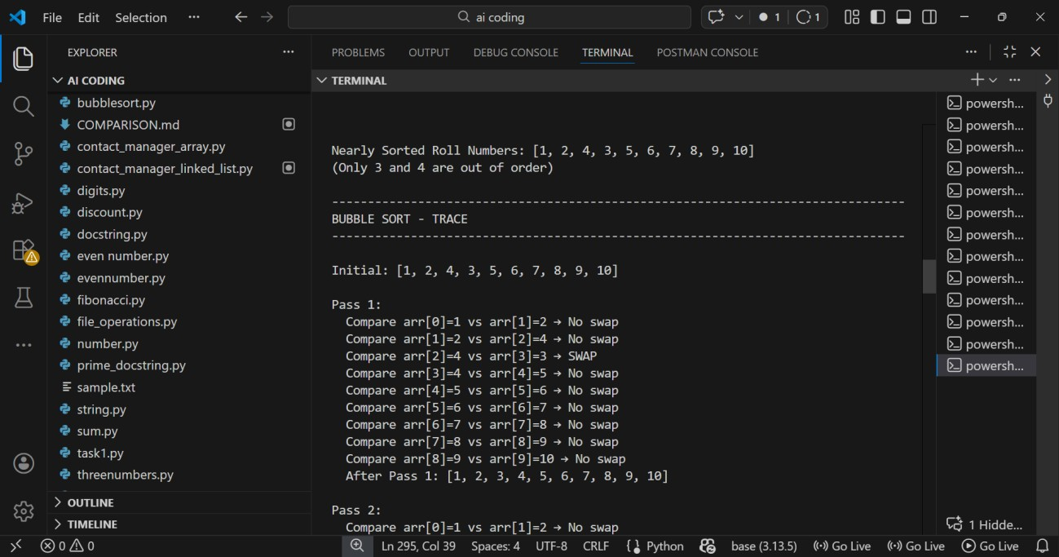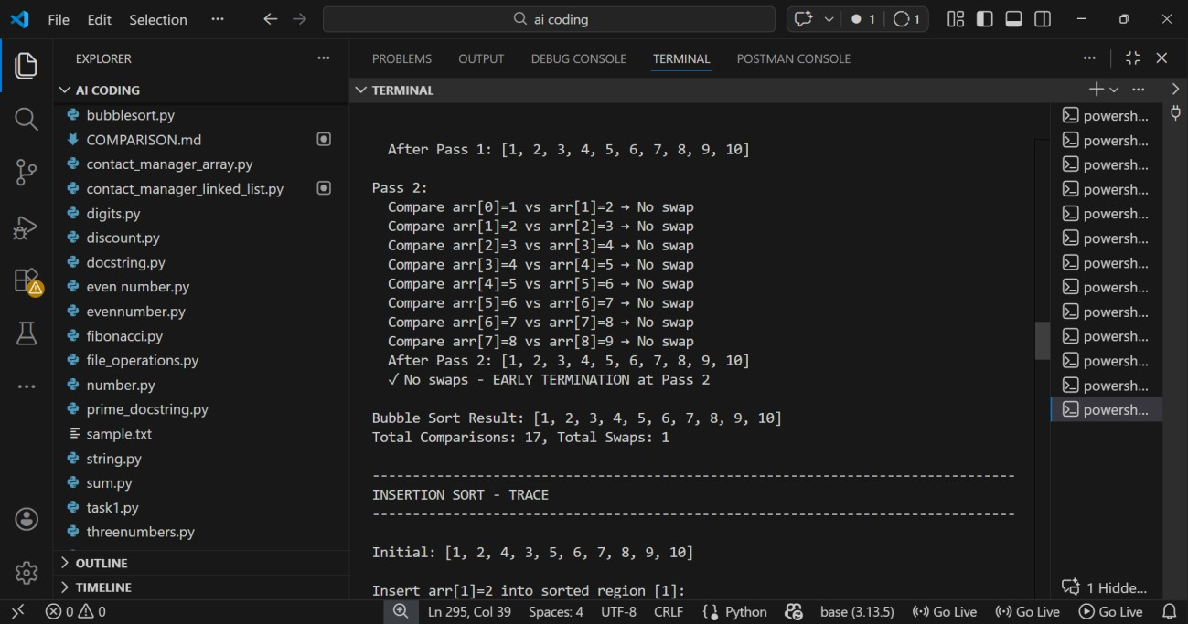
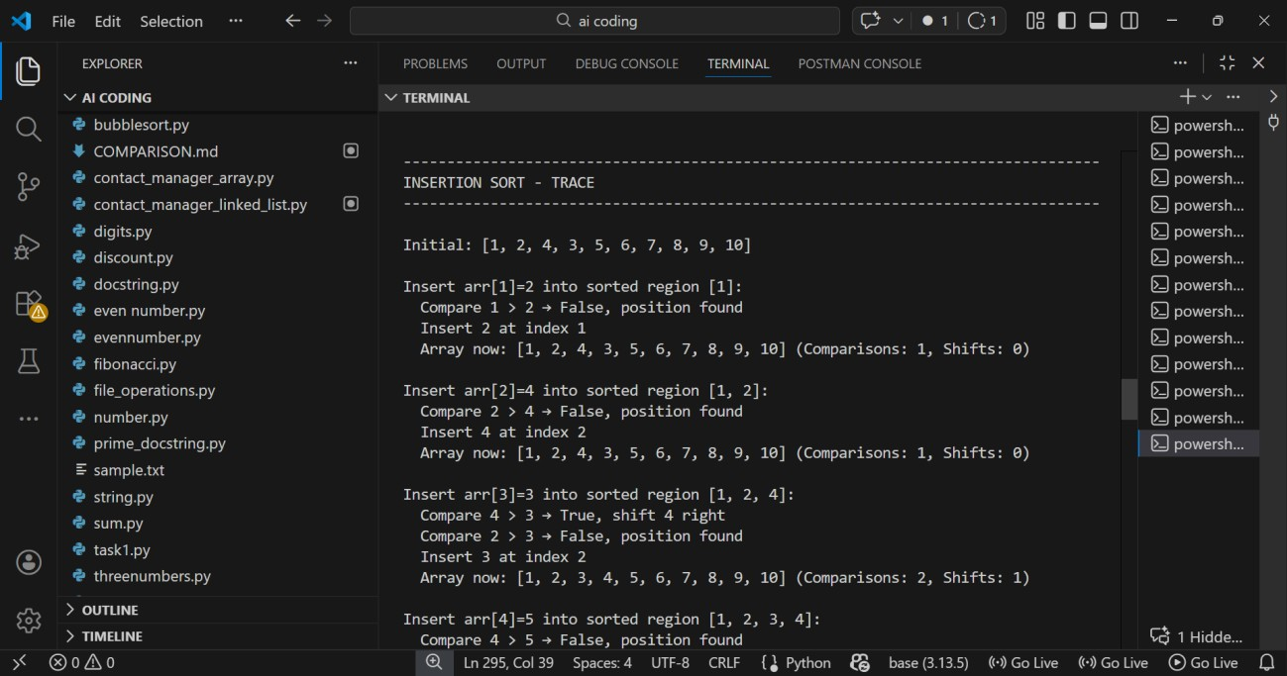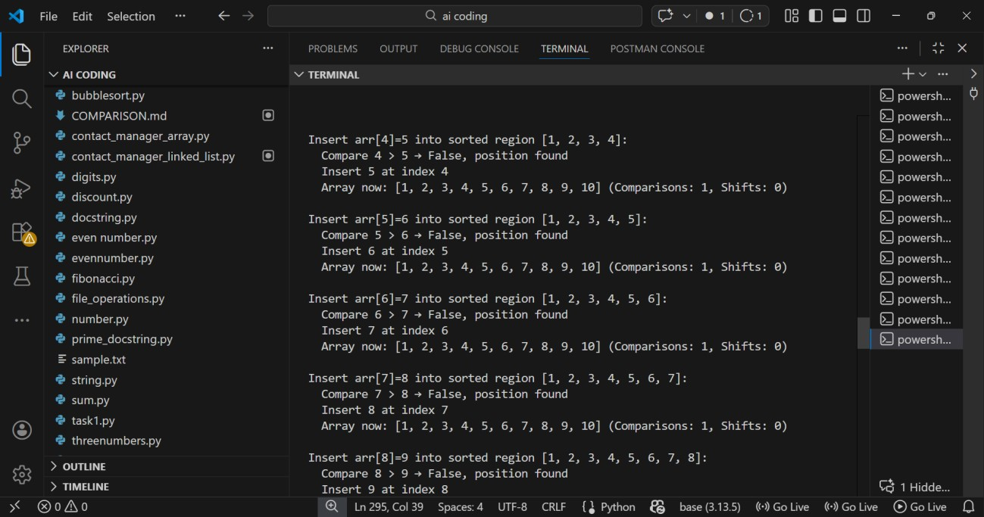

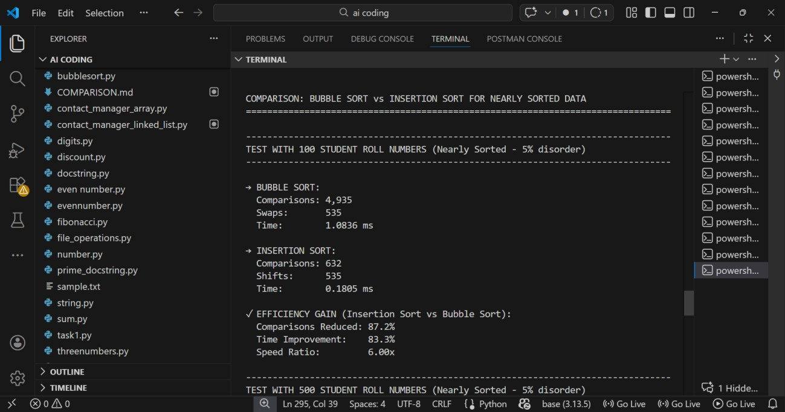
Task 3:
Searching Student Records in a
Database
Scenario
You are developing a student information portal where users search for student records by roll number.
Prompt:
Implement Linear Search and Binary Search in Python to search student records by roll number. Add proper docstrings explaining parameters and return values. Explain when Binary Search is applicable and compare performance differences. Also provide time complexity and a short observation comparing results on sorted vs unsorted lists.
Code:

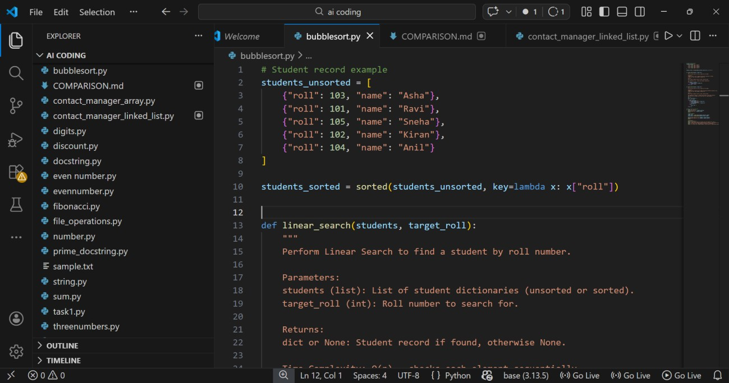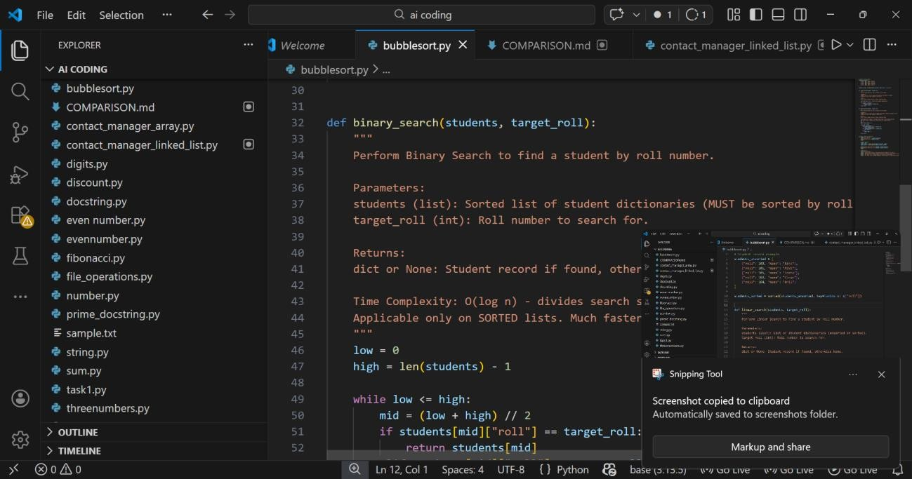

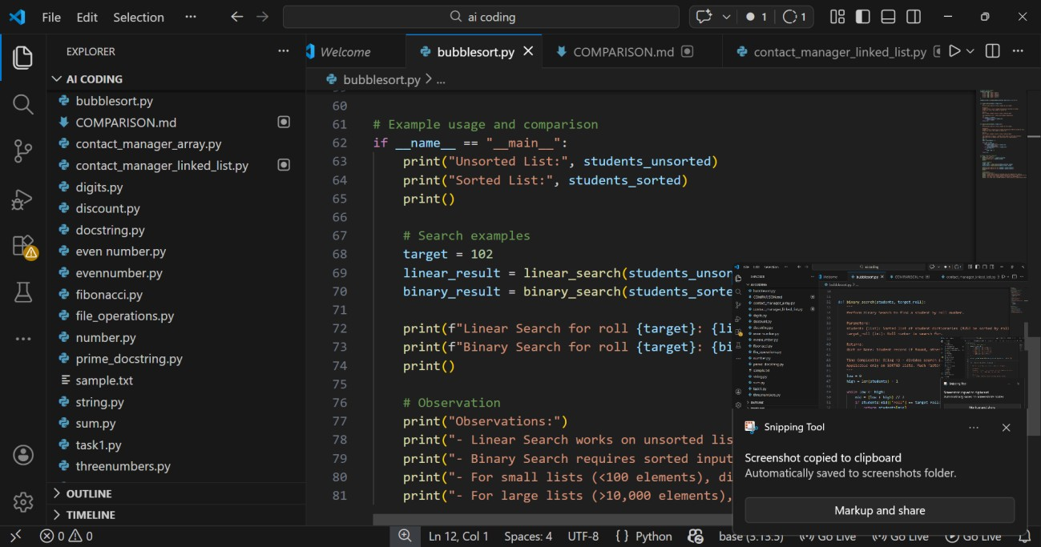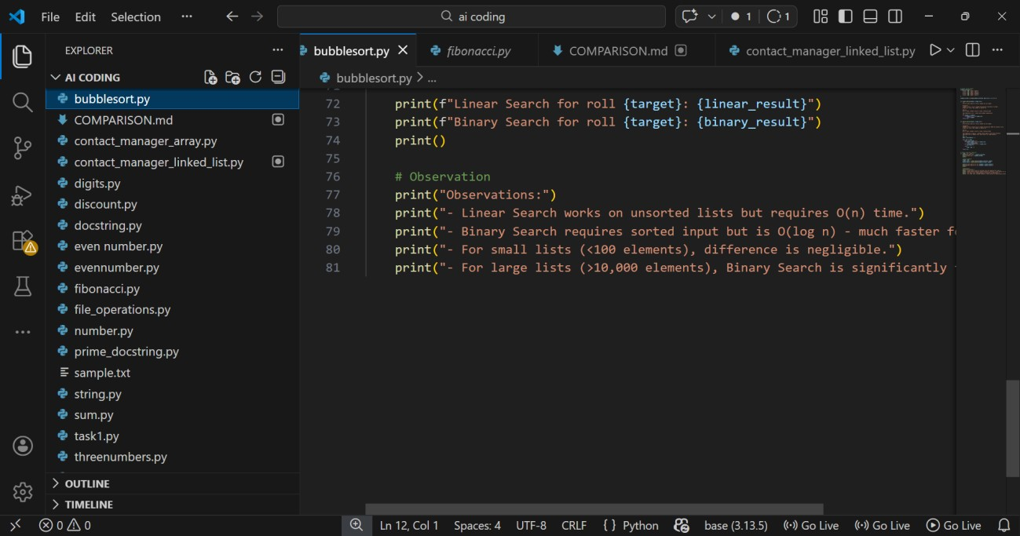
Output:
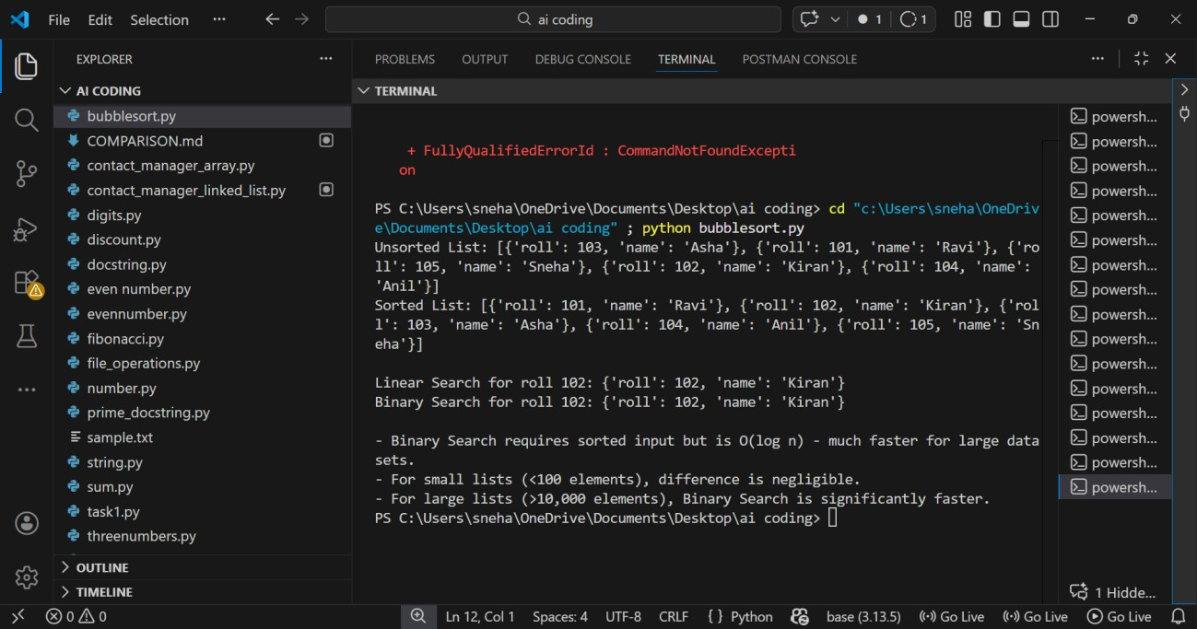
Explanation:
- Linear Search checks each student record one by one, so it works even if the data is unsorted.
- Binary Search divides the list into halves repeatedly, but it only works when the student records are sorted by roll number.
- Linear Search has O(n) time complexity, meaning it may take longer as the number of records increases.
- Binary Search has O(log n) time complexity, making it much faster for large datasets.
- Use Linear Search for small or unsorted data, and Binary Search for large sorted databases where quick searching is needed.
Task 4:
Choosing Between Quick Sort and
Merge Sort for Data Processing
Scenario: You are part of a data analytics team that needs to sort large datasetsreceived from different sources (random order, already sorted, and reverse sorted).
Prompt:
Complete recursive Quick Sort and Merge Sort functions with docstrings. Explain how recursion works, test on random, sorted, and reverse-sorted data, and compare time complexities with practical use cases.
Code:
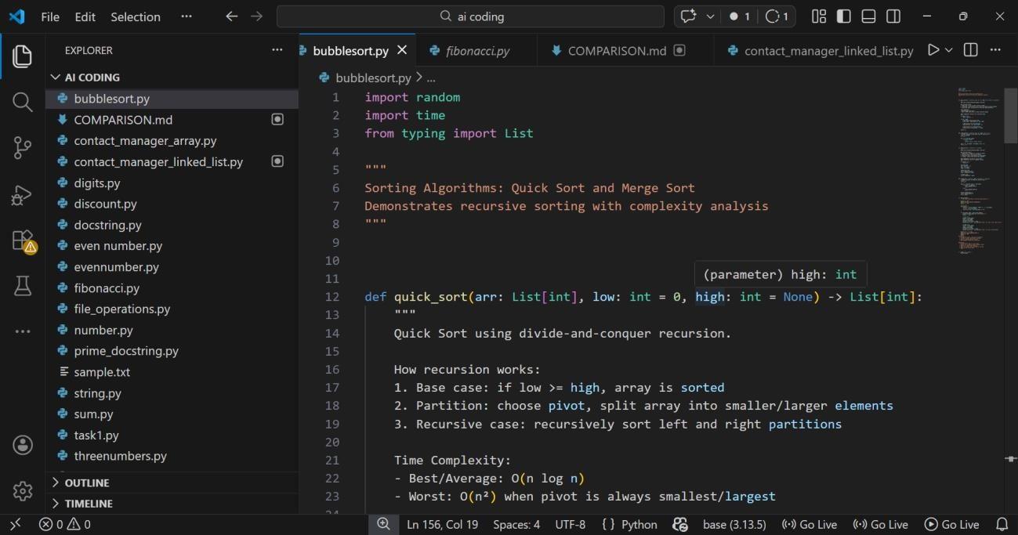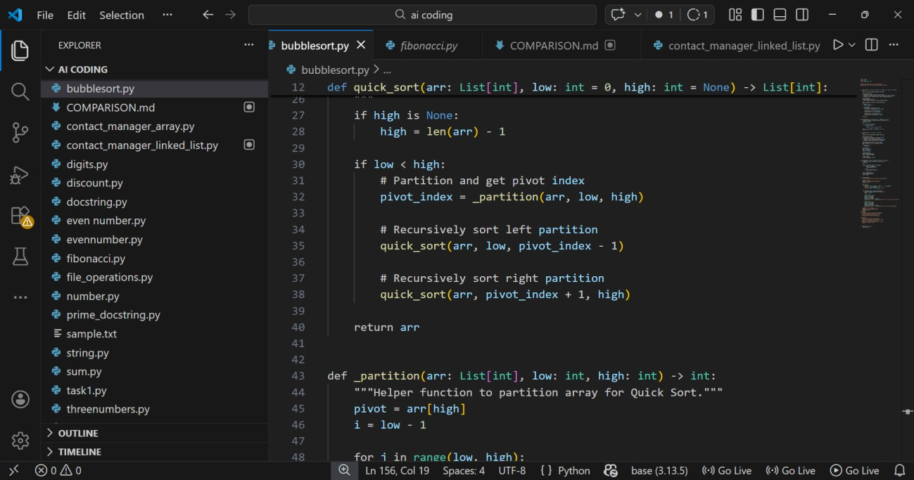

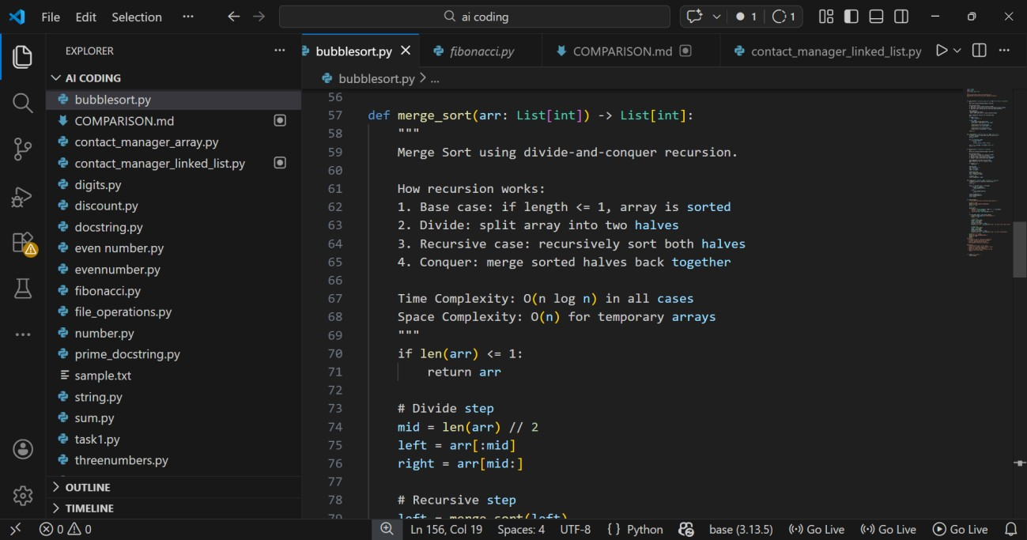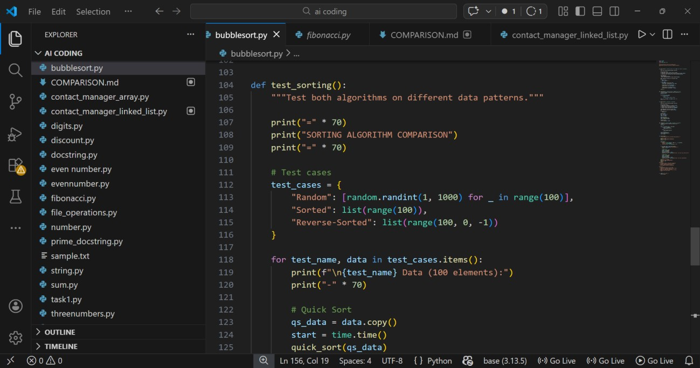

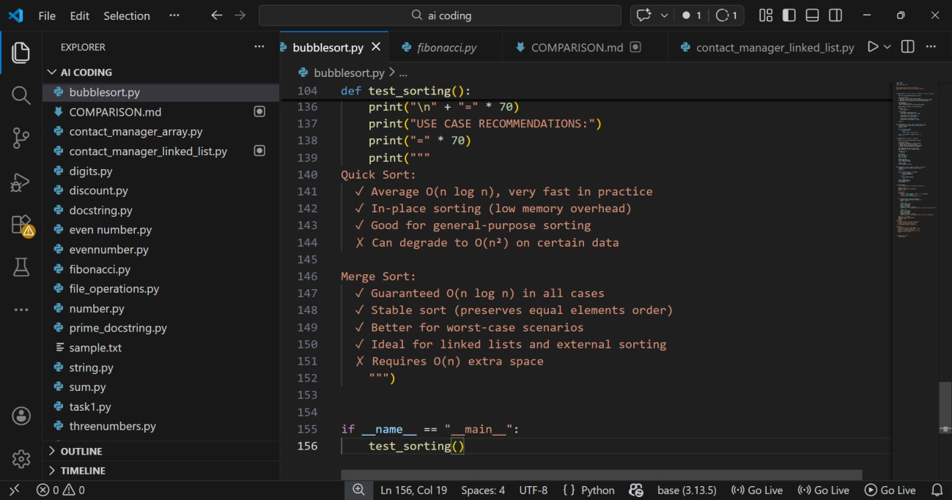
Output:
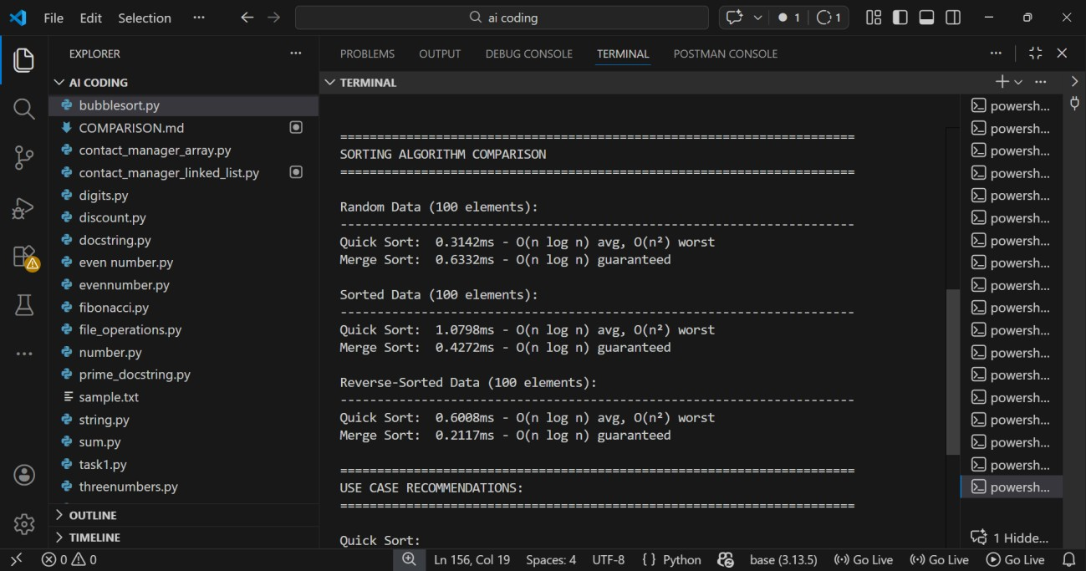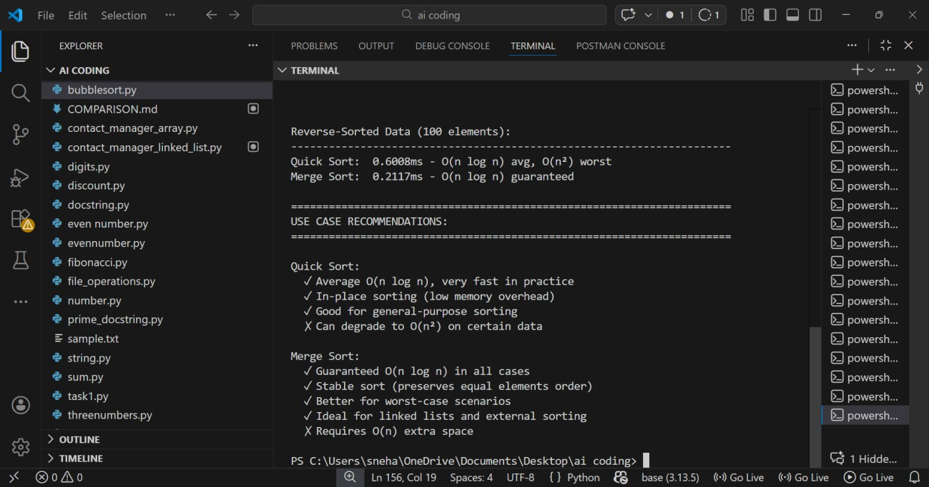
Explanation:
- Quick Sort uses a pivot to divide the dataset into smaller parts and sorts them recursively, making it fast for random data.
- Merge Sort divides the dataset into halves and merges them after sorting, ensuring stable and consistent performance.
- Recursion works by repeatedly breaking the problem into smaller subproblems until they become simple to solve.
- Quick Sort is usually faster in practice but can perform poorly on already sorted or reverse-sorted data (worst case).
- Merge Sort guarantees O(n log n) performance and is preferred when stable sorting or predictable speed is required.
Task 5:
Optimizing a Duplicate Detection Algorithm
Scenario
You are building a data validation module that must detect duplicate user IDs in a large dataset before importing it into a system.
Prompt:
Implement a brute-force duplicate detection algorithm using nested loops, analyze its time complexity, then optimize it using a set or dictionary and compare performance for large datasets.
Code:

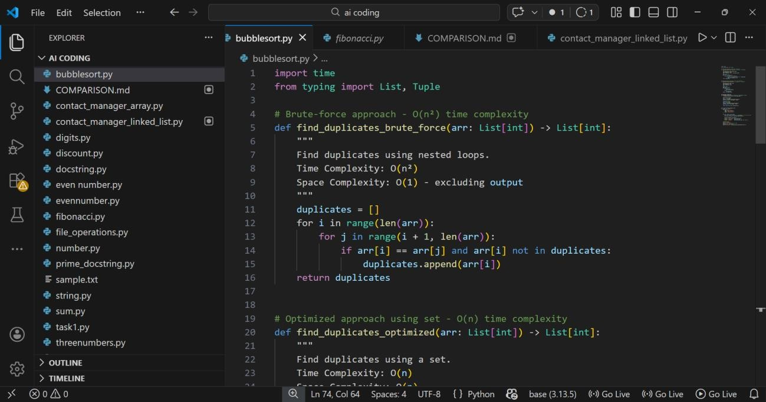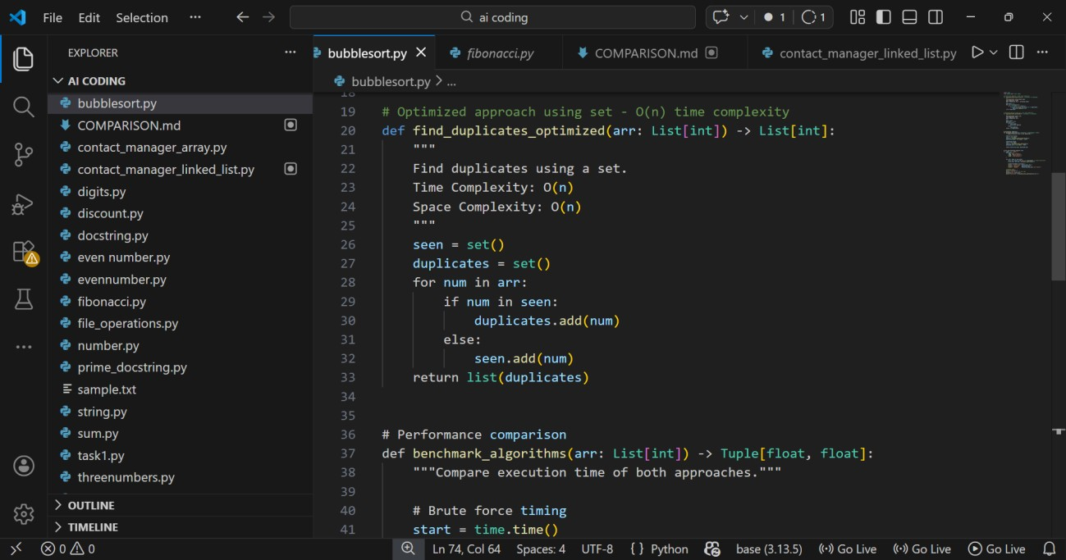

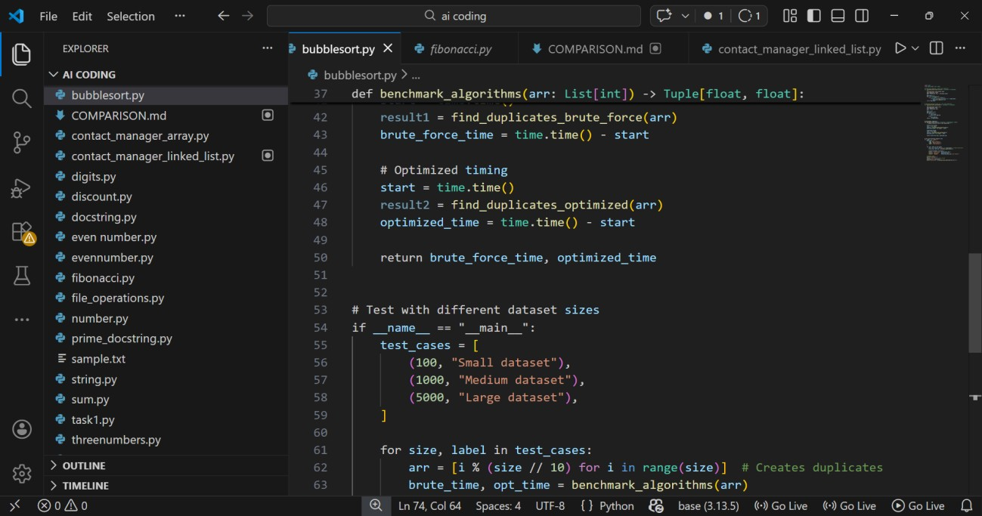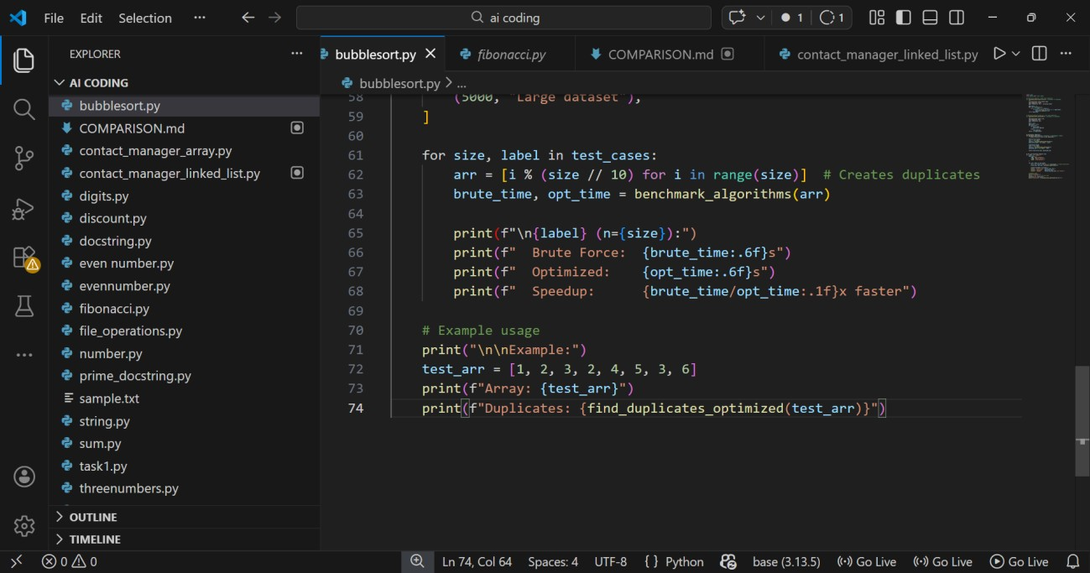
Output:
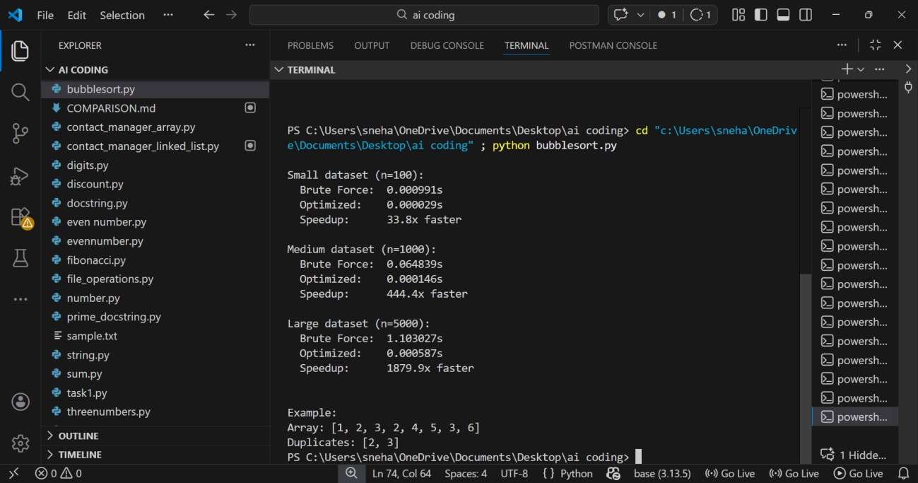
Explanation:
- The brute-force method uses nested loops to compare each user ID with every other ID, resulting in O(n²) time complexity.
- This approach becomes slow for large datasets because the number of comparisons grows rapidly.
- The optimized method uses a set or dictionary to track seen IDs, reducing the time complexity to O(n).
- Performance improves because each ID is checked only once instead of repeatedly comparing with all others.
- For large inputs, the optimized approach runs much faster and is preferred for real-world data validation systems.

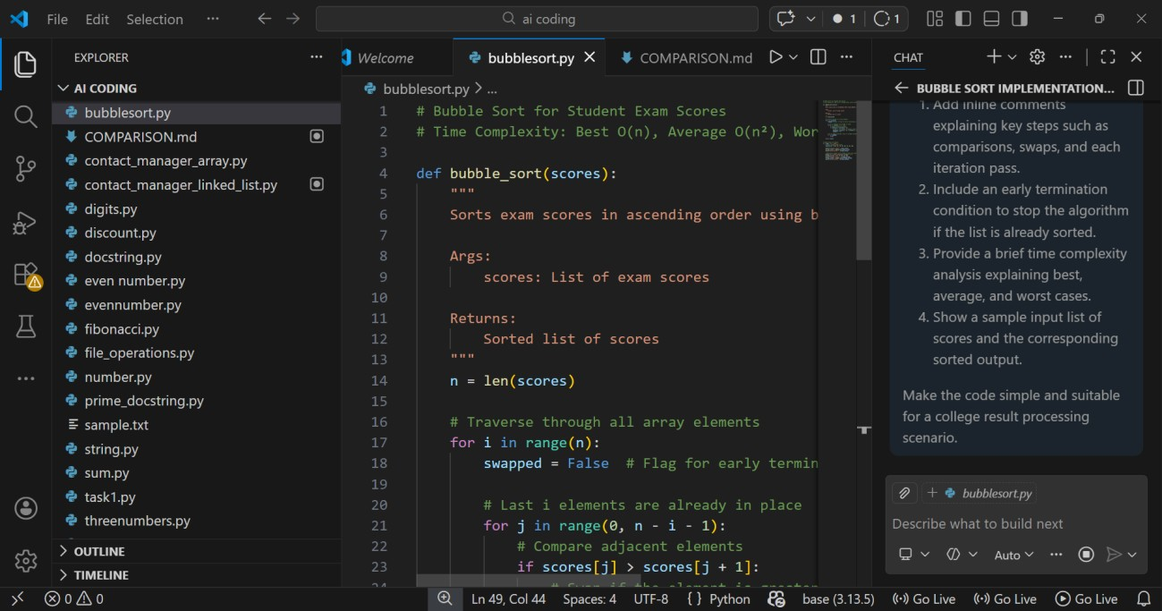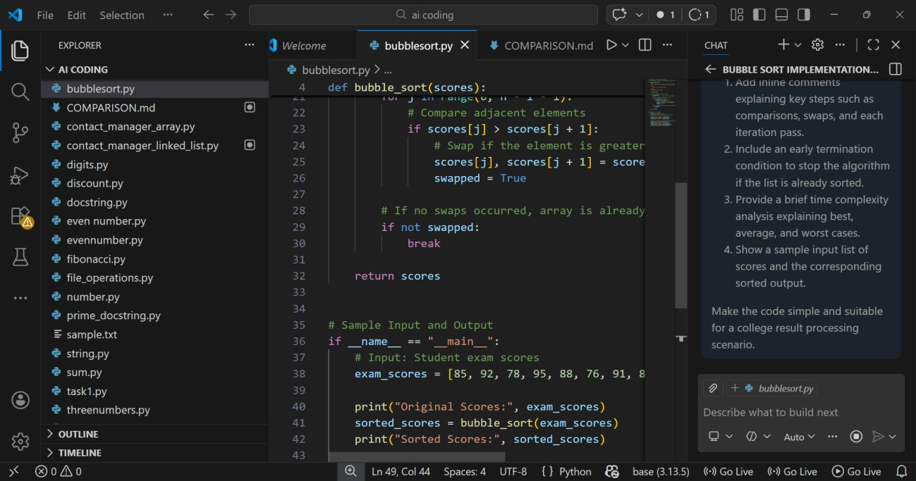

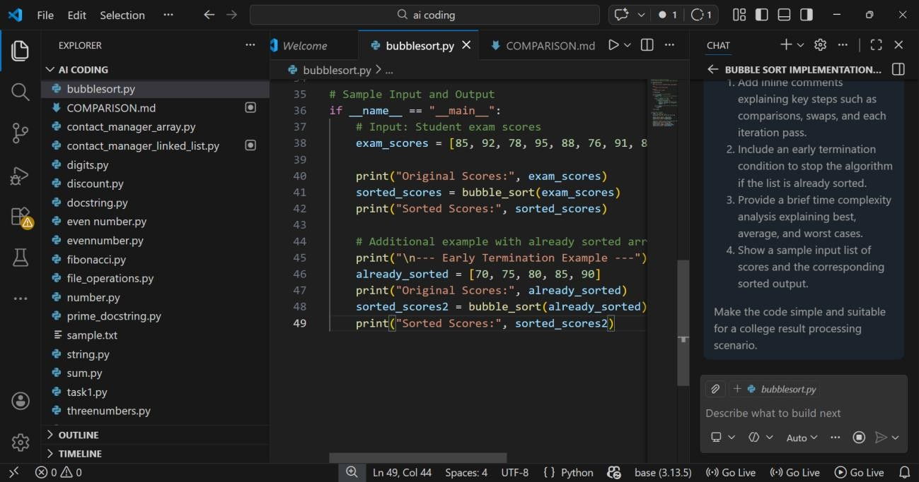
Output:
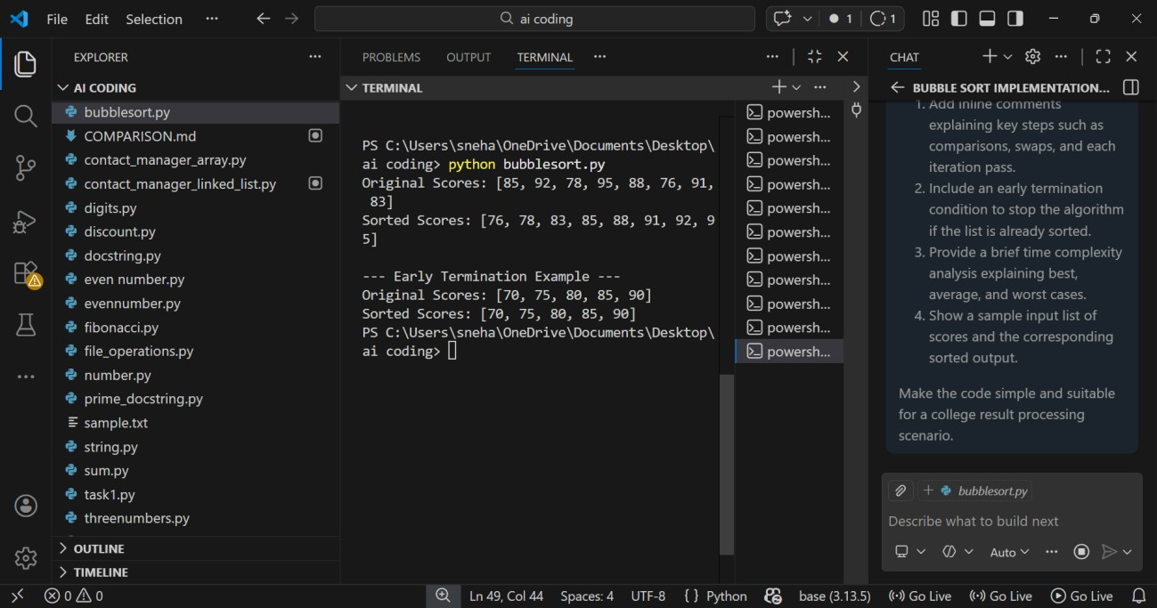
Explanation:
- Bubble Sort compares adjacent exam scores and swaps them if they are in the wrong order.
- It repeats multiple passes until all scores are arranged correctly.
- After each pass, the largest score moves to its correct position (“bubbles up”).
- If no swaps happen in a pass, the algorithm stops early because the list is already sorted.
- Time complexity: Best — O(n), Average — O(n²), Worst — O(n²).
Task 2:
Improving Sorting for Nearly Sorted
Attendance Records
Scenario
You are maintaining an attendance system where student roll numbers are already almost sorted, with only a few late updates. Prompt:

